NAME : DHANUSHUYA. E
BATCH NO : DA | TN-FNB03
CONTACT : +91-9629572210
EMAIL ID : dhanushuyaezhilarasan@gmail.com
DOMAIN : SALES & E-COMMERCE
PROJECT TITLE :

DATA CLEANING AND VISUALIZATION USING EXCEL AND POWER BI IN COFFEE SALES PERFORMANCE

SUBMISSION : 22.08.2025

MENTOR : KUMARAN

DATASET LINK :

https://docs.google.com/spreadsheets/d/1kisDj38u7joelmvqPNiD-UcZY-FuP6po/edit?usp=sharing&ouid=104802036822596101161&rtpof=true&sd=true

DATA CLEANING AND TRANSFORMING

Splitting date and time column using text to column delimiters
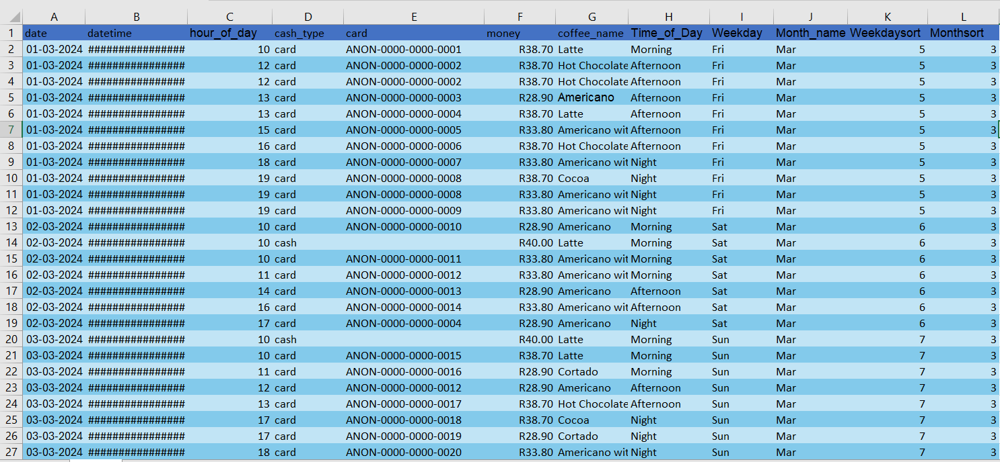

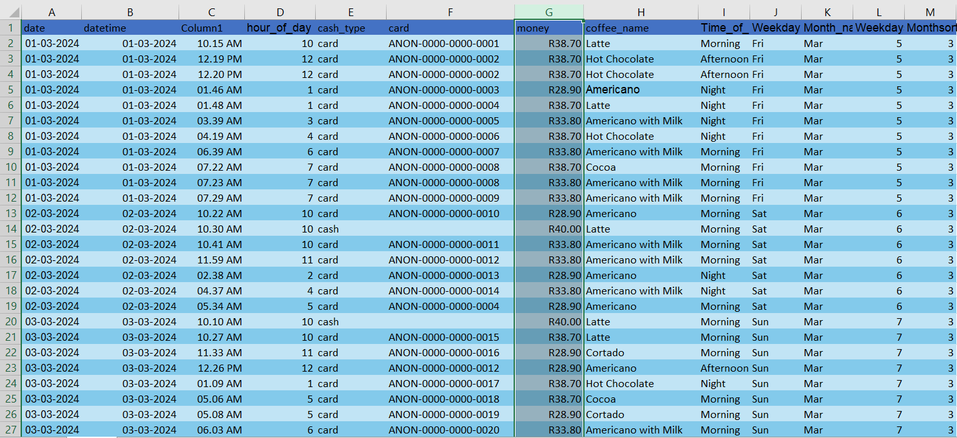

Changed datatype of Time into Time type
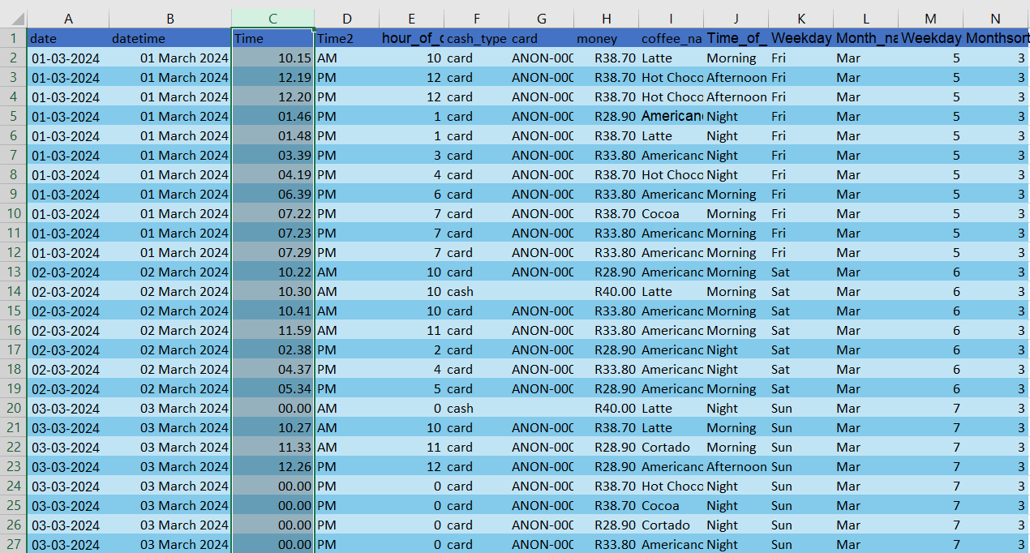
Merge time and time 2 column in single column
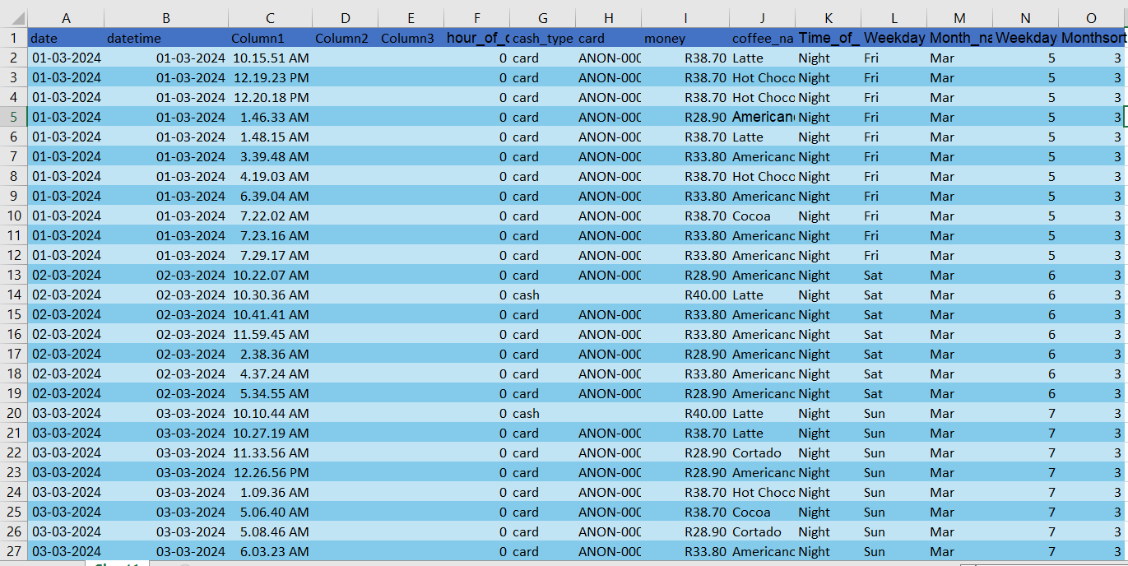

Removing duplicate columns in datasheet

Changed money column datatype into currency format
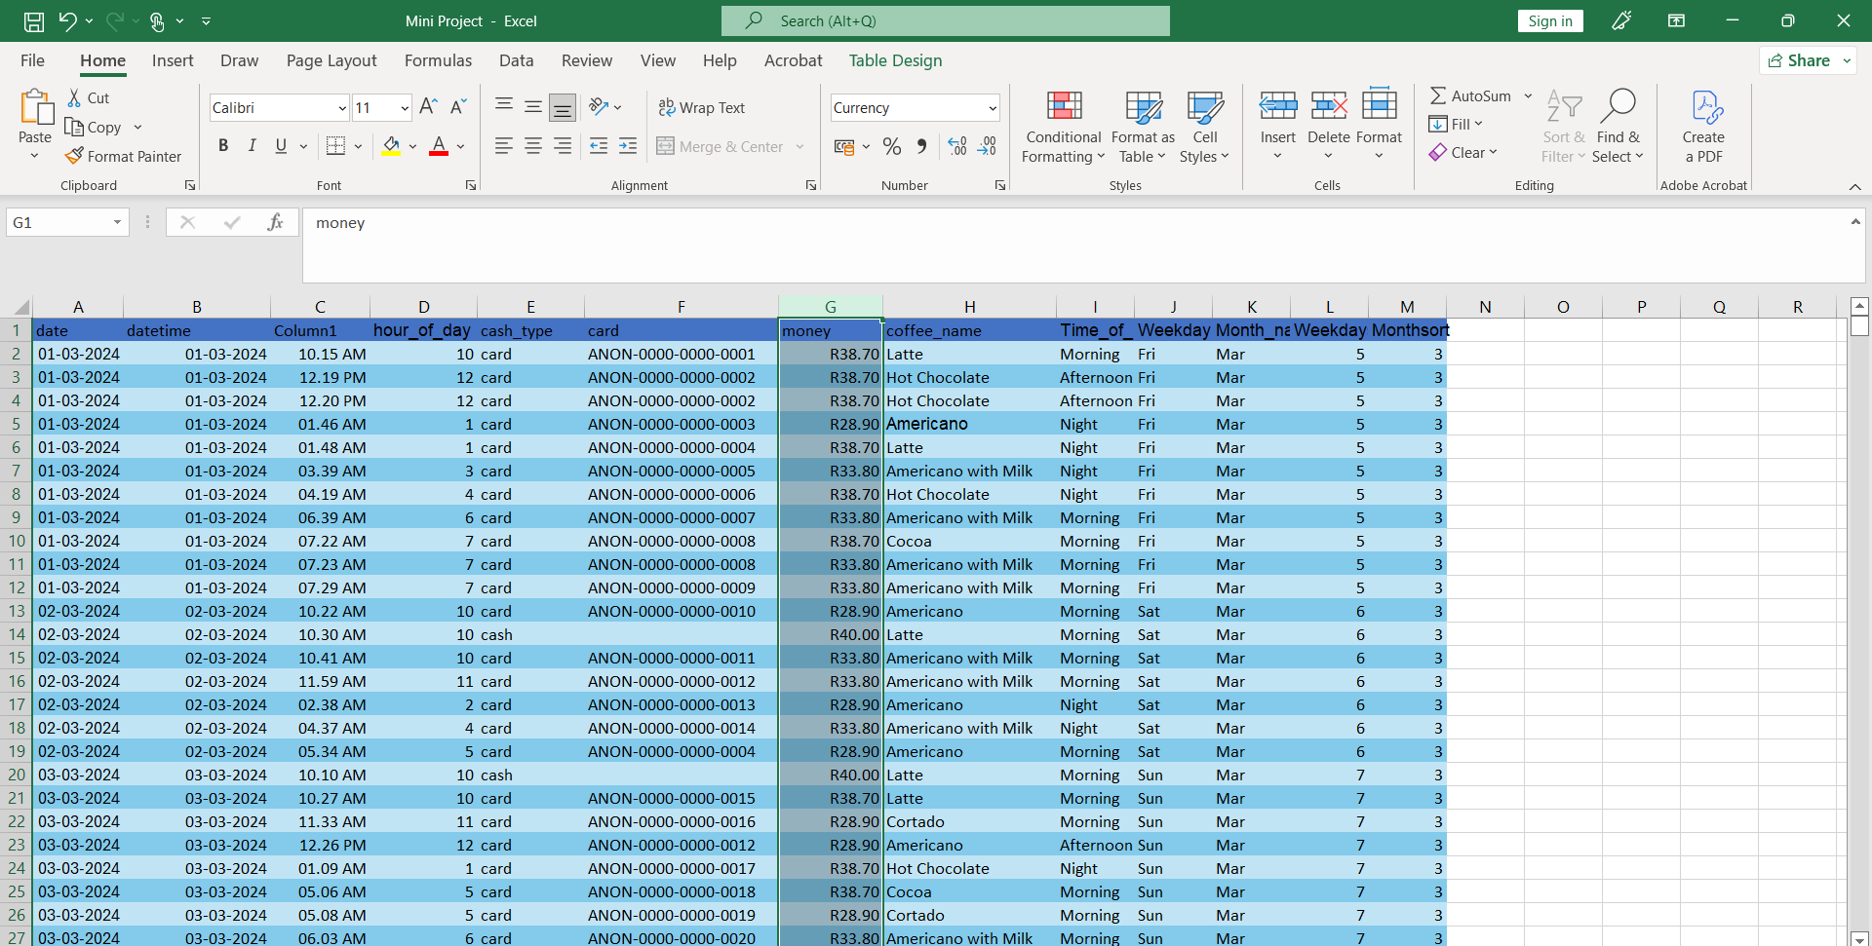

Create impact cards column to fill the null cells with cash in cards column using if function
Replacing cash according to cash type

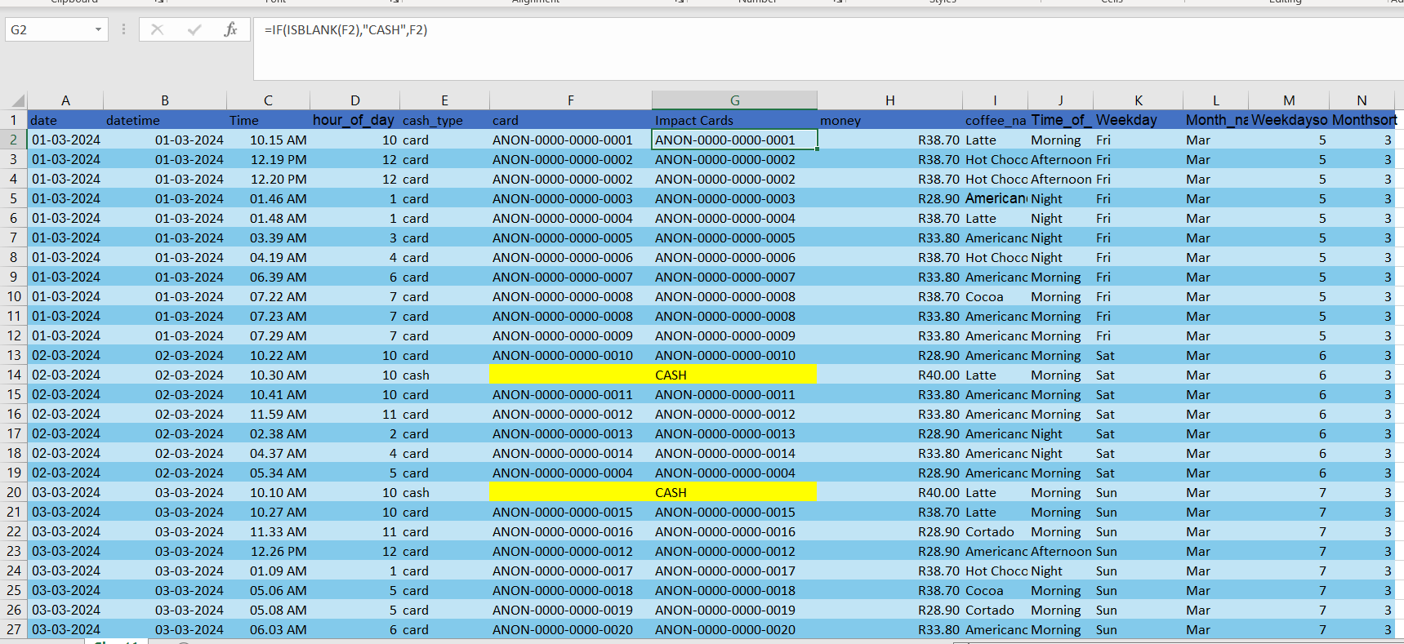

Create icon bar in the money column using conditional formatting

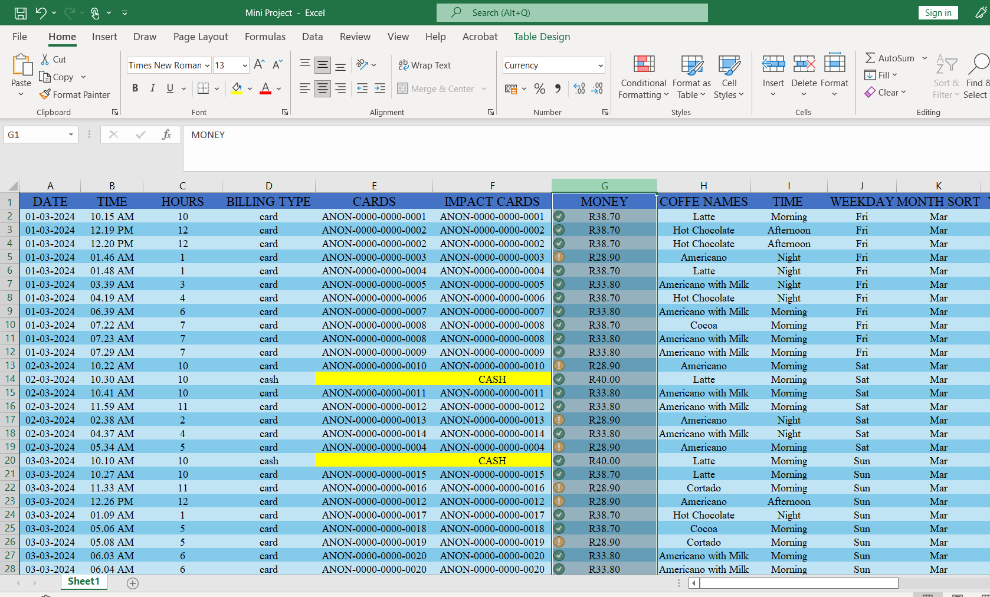

Create Bar scale in hours column using conditional formatting

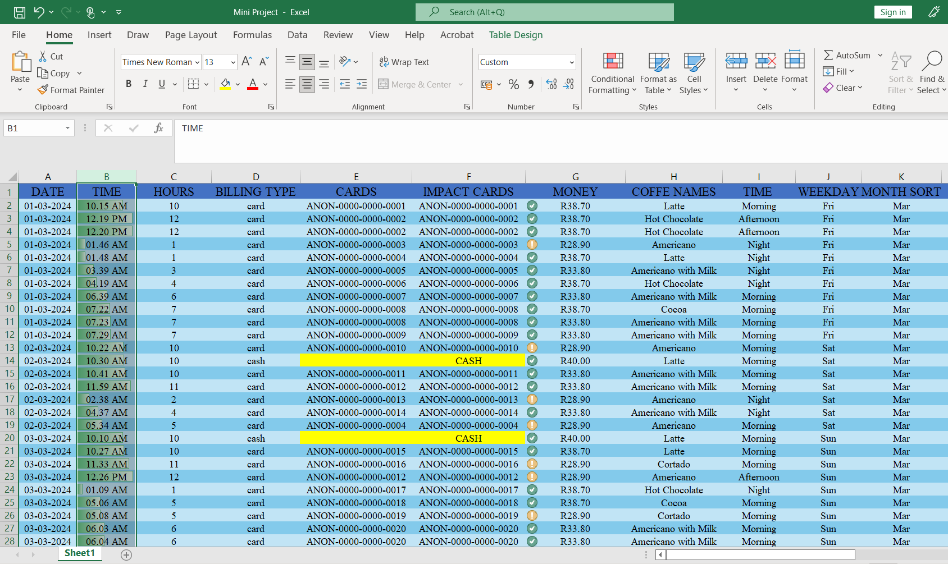

Create a new column named as year sort using text function

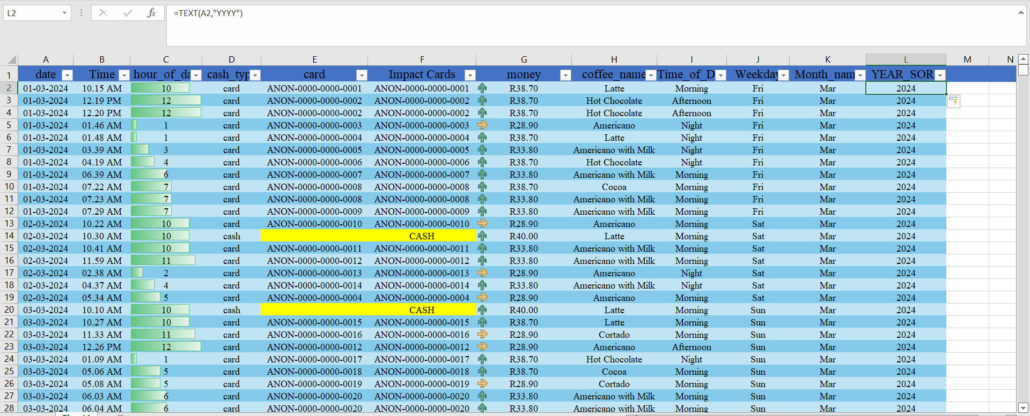

Changing cell format style in the datasheet

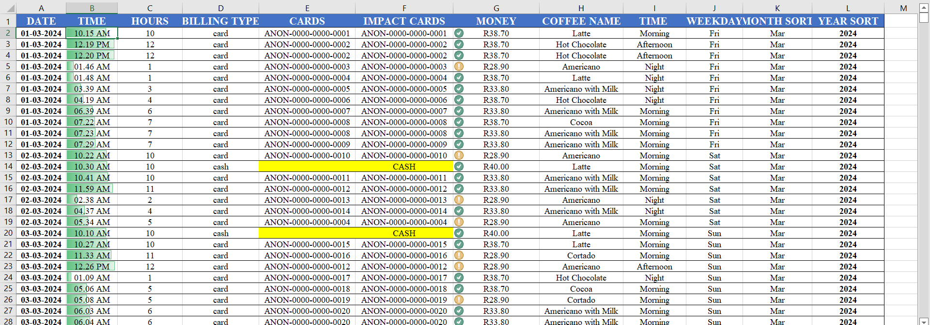

Standardized format of changing font style and alignment in datasheet

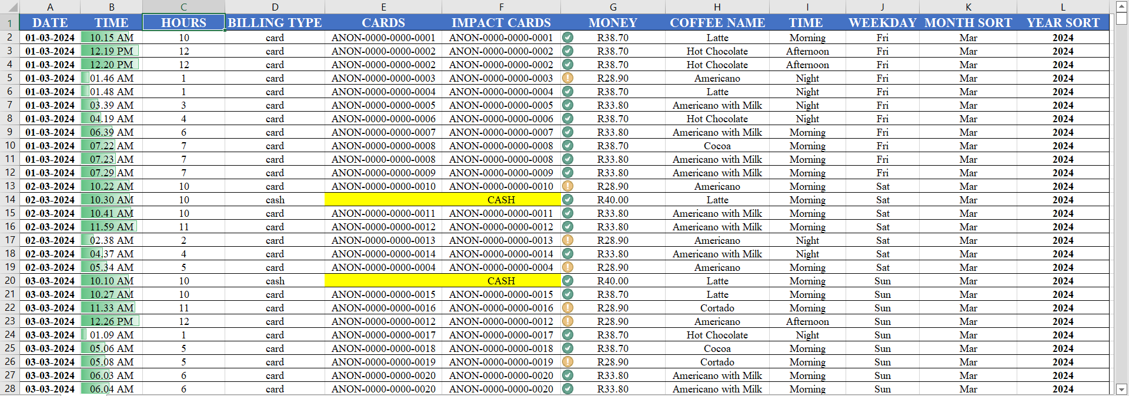

Import excel datasheet into power bi

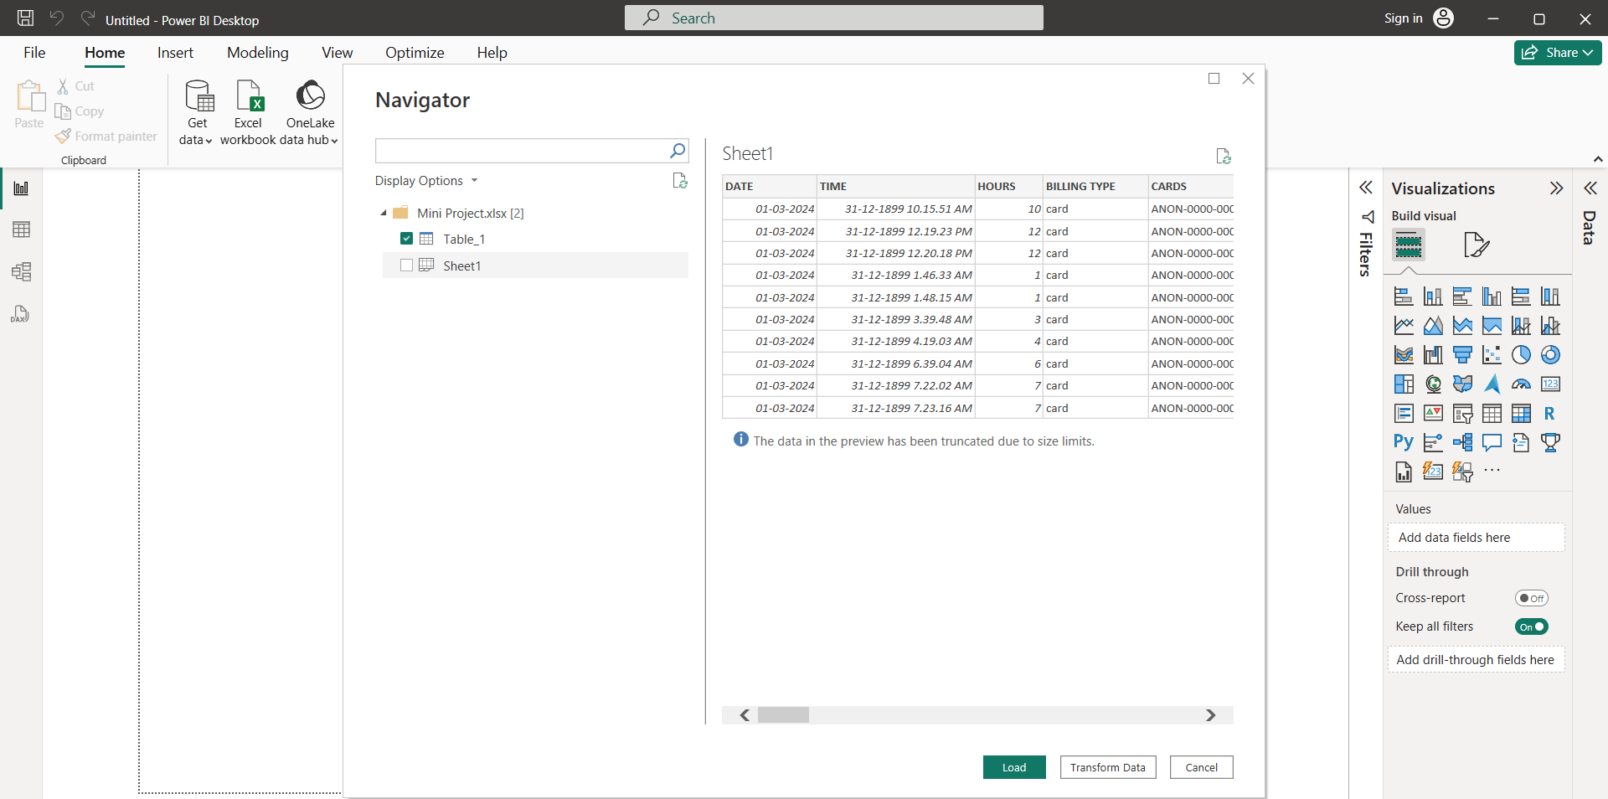

Transforming excel datasheet in Power bi

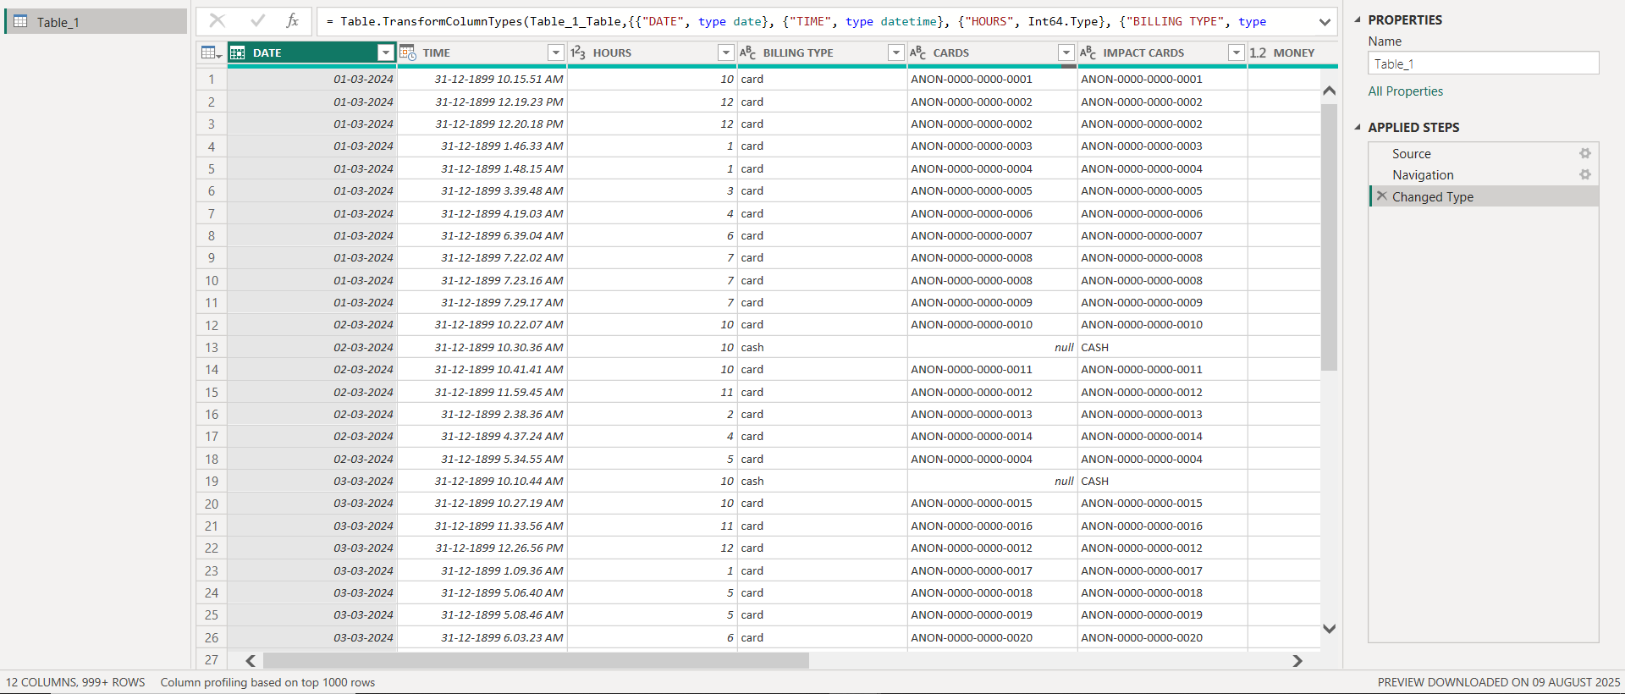

Split column into date and time

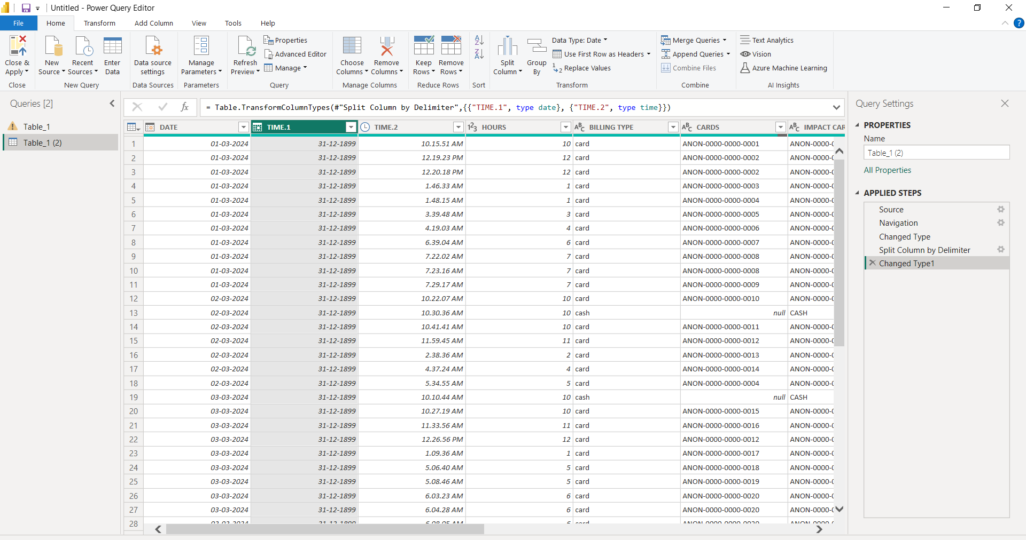

Removing duplicate columns (Extract date column)

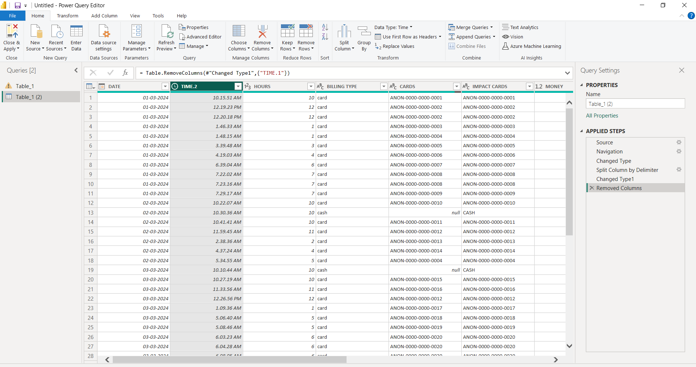

Changed money column datatype into fixed decimal number

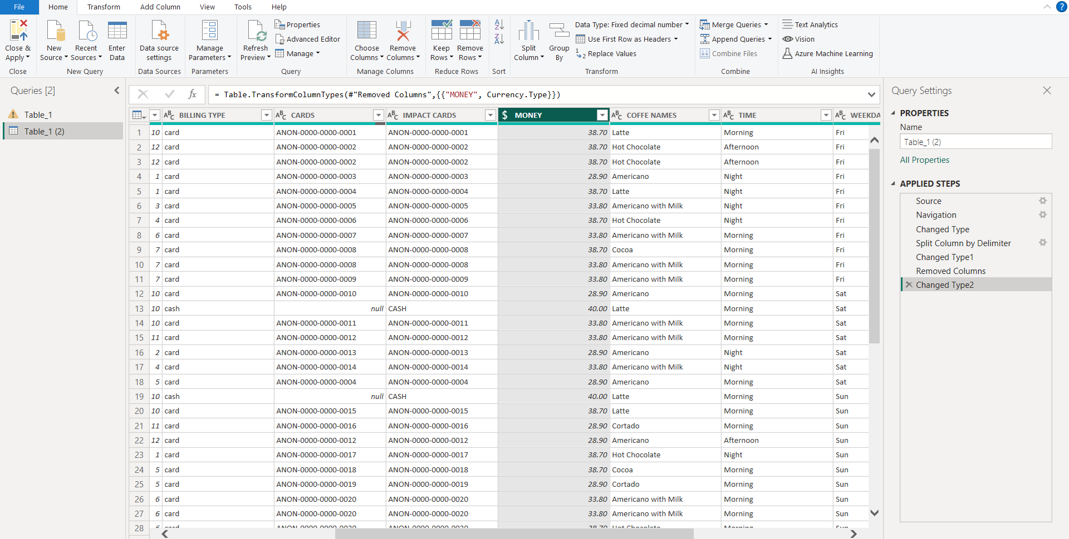

Renamed time 2 column as time and changed datatype

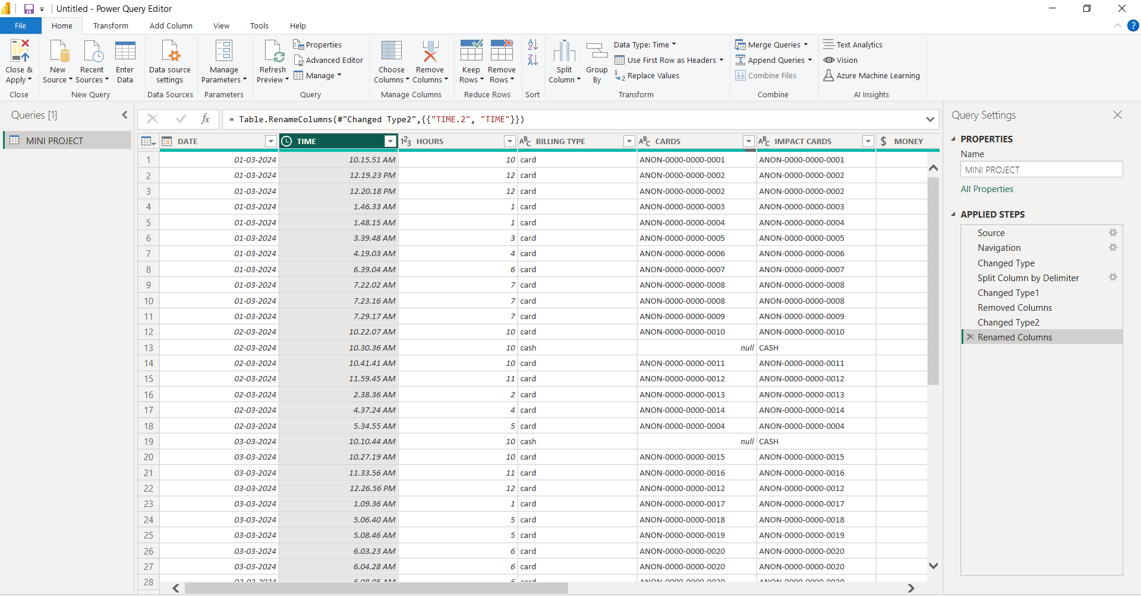

DATA VISUALIZATION

Visualizing Average of money with month sort using pie chart

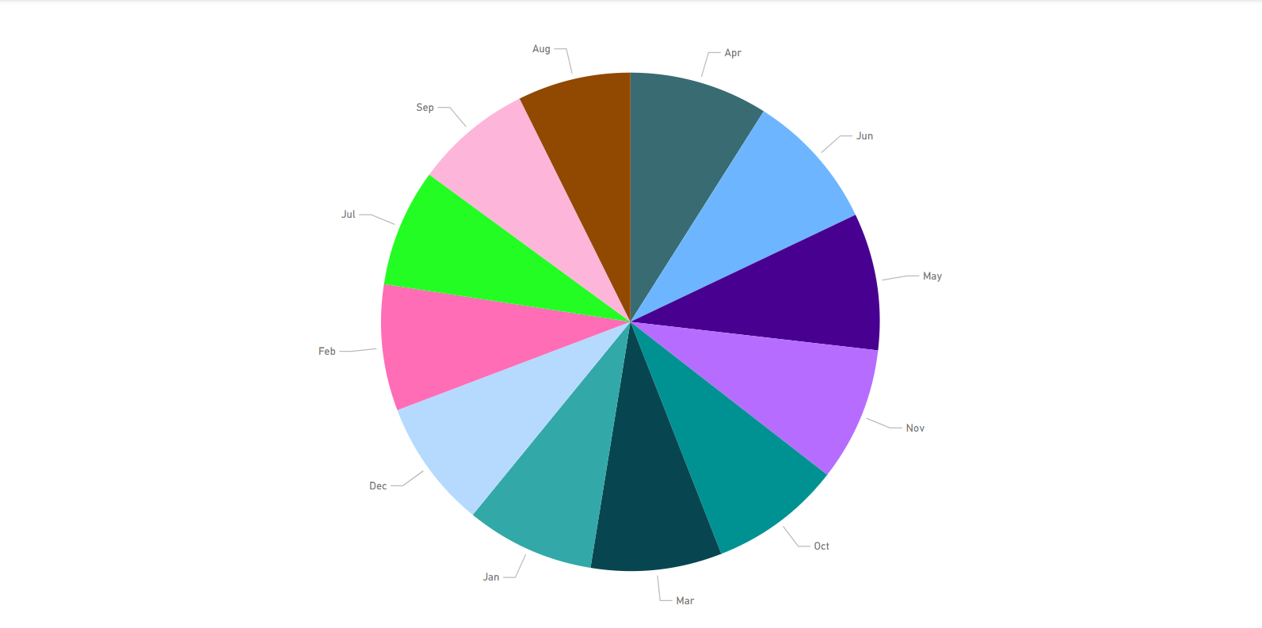

Visualizing selling coffee based on names with count of hours
Using column chart

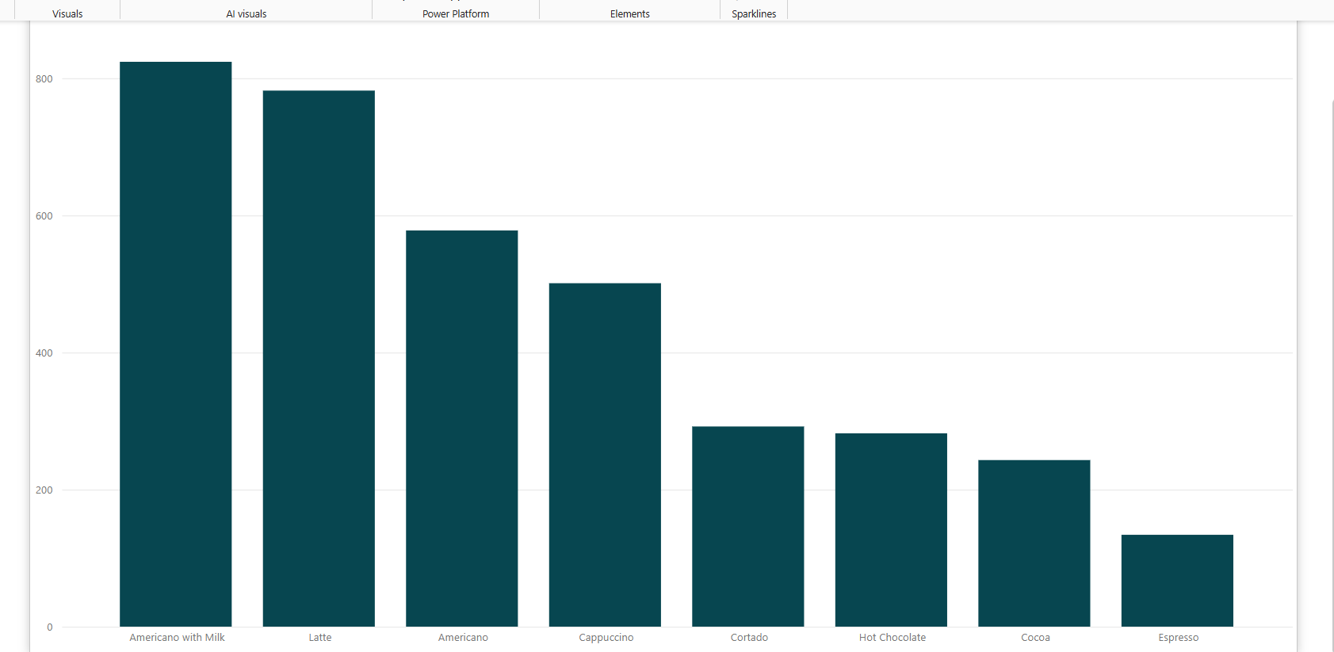

Visualizing maximum number of years sort based on the sales using cards

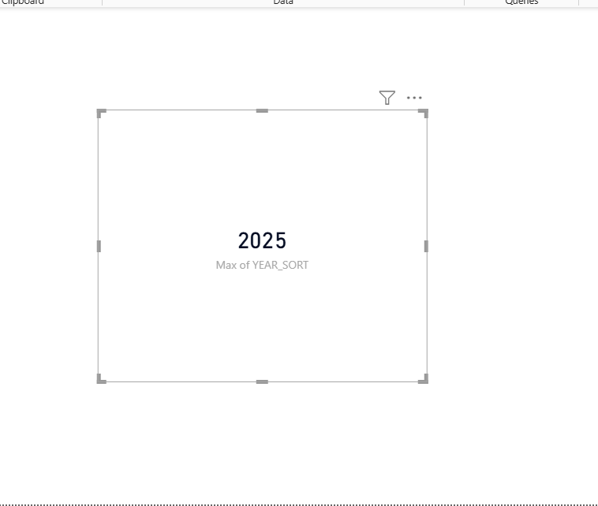

Visualization sums of amount based on coffee names with count of hours and years sort using scatter plot

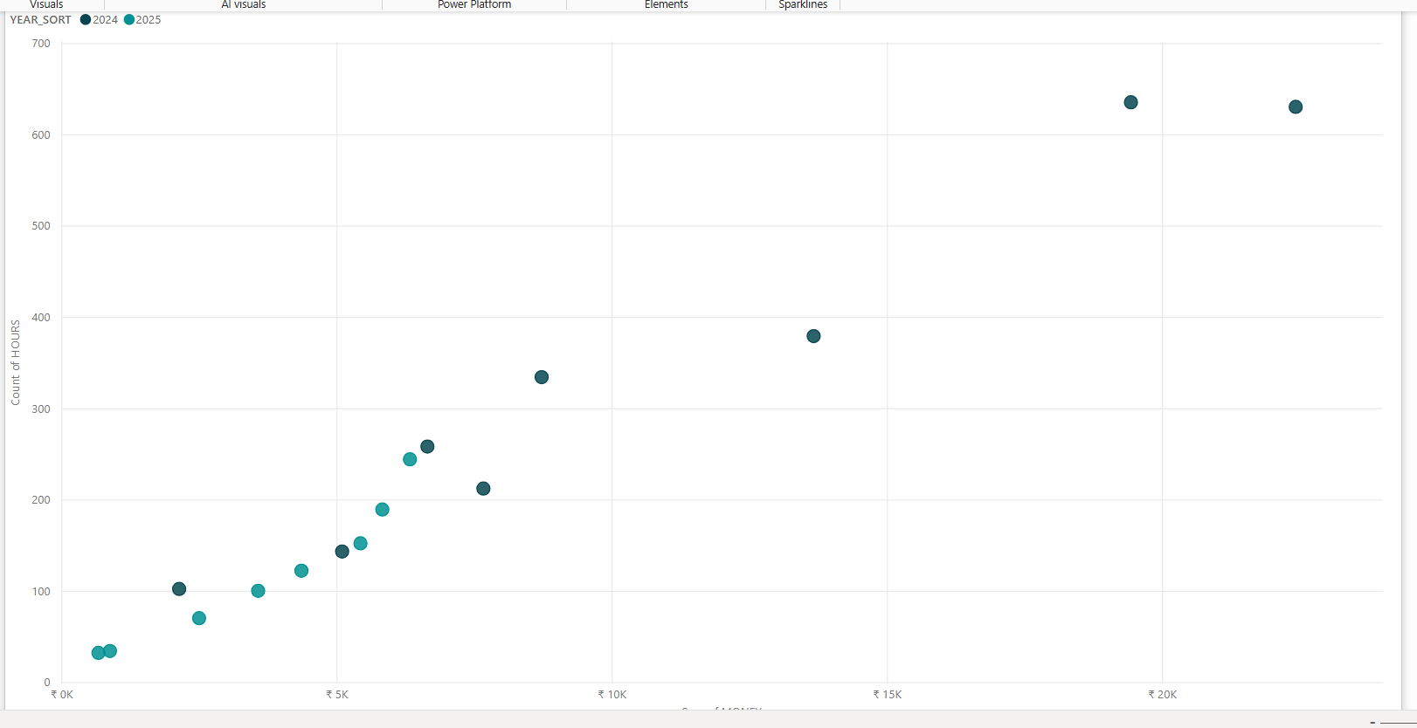

Visualization of sum of money with sort of year and coffee names using tree map

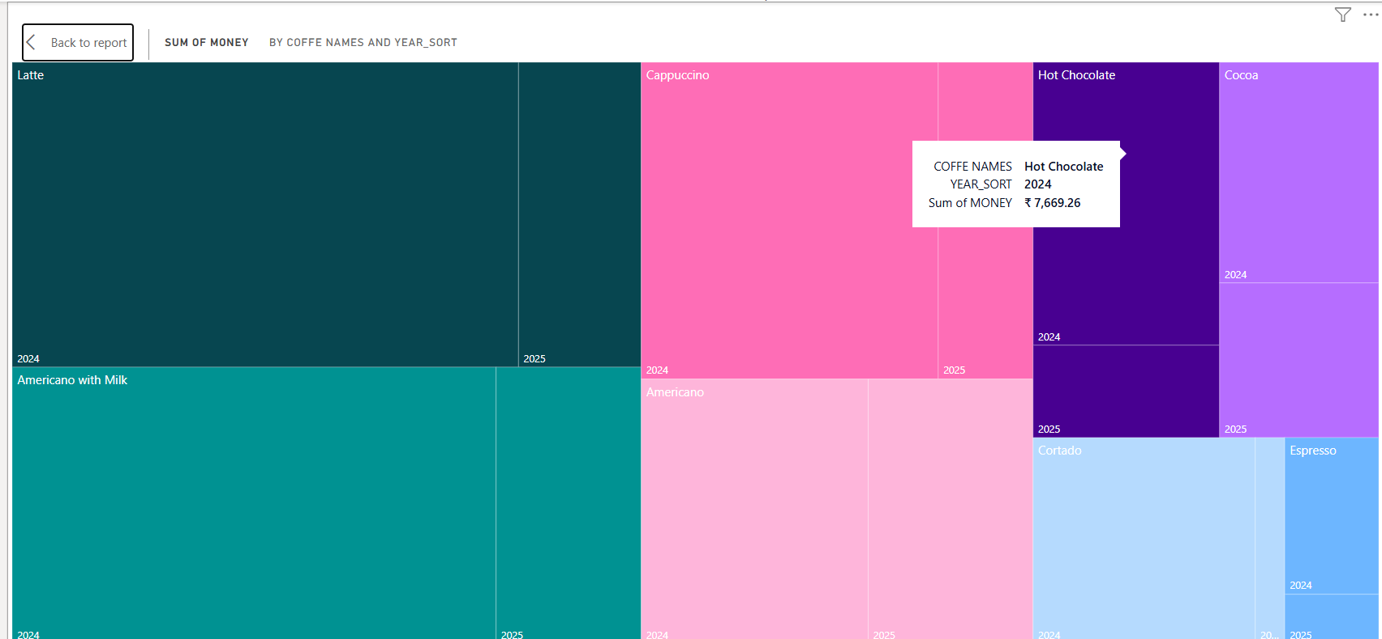

Visualization of average of money on the basics of month and year using table

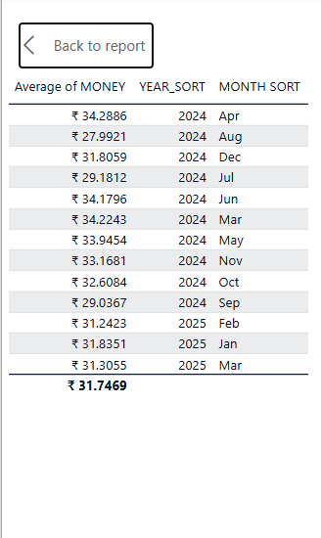

Visualization of coffee names with sum of money using funnel chart

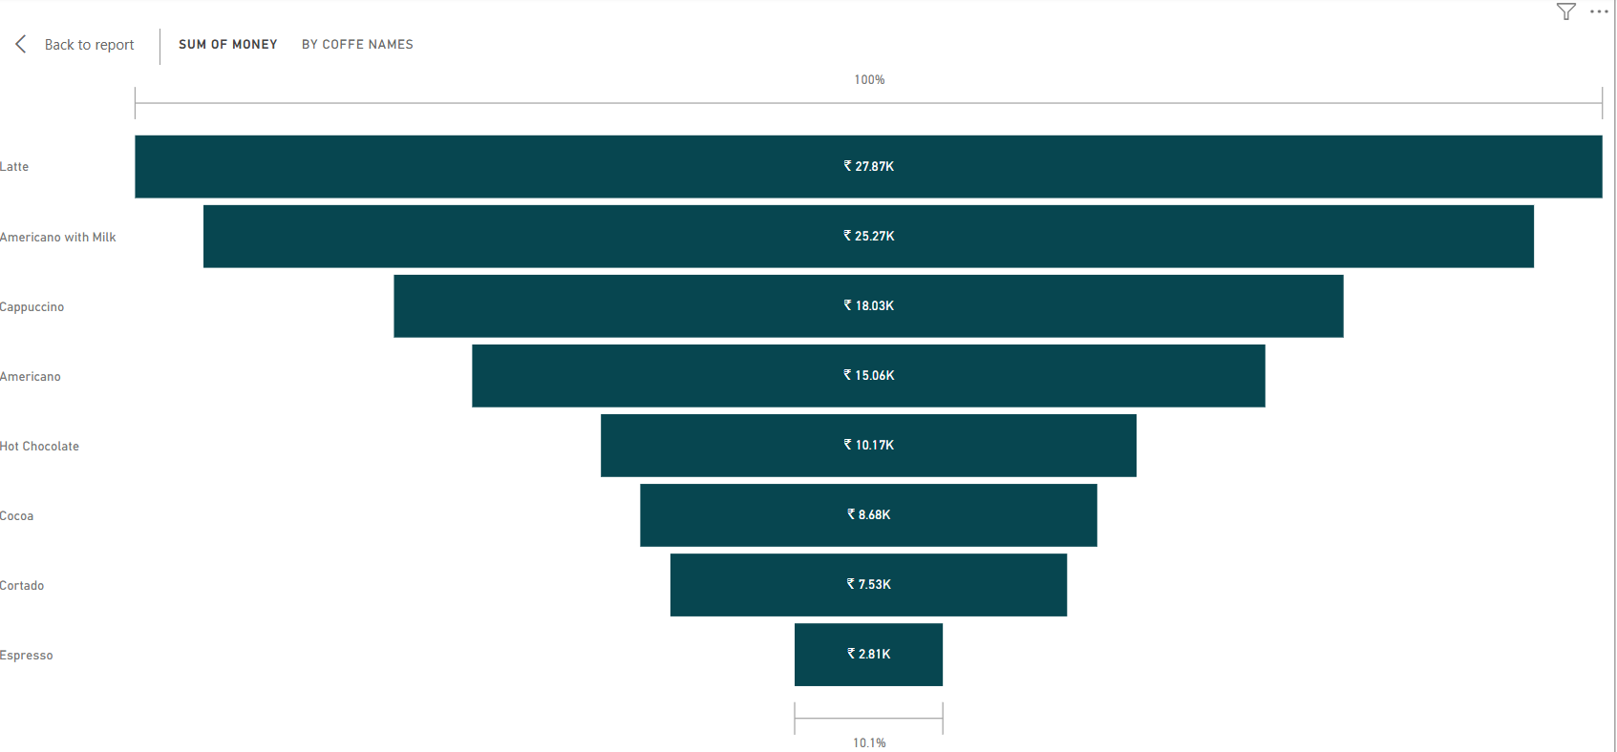

Adding Slicers to the chart which includes money, hours, coffee names ,month and years

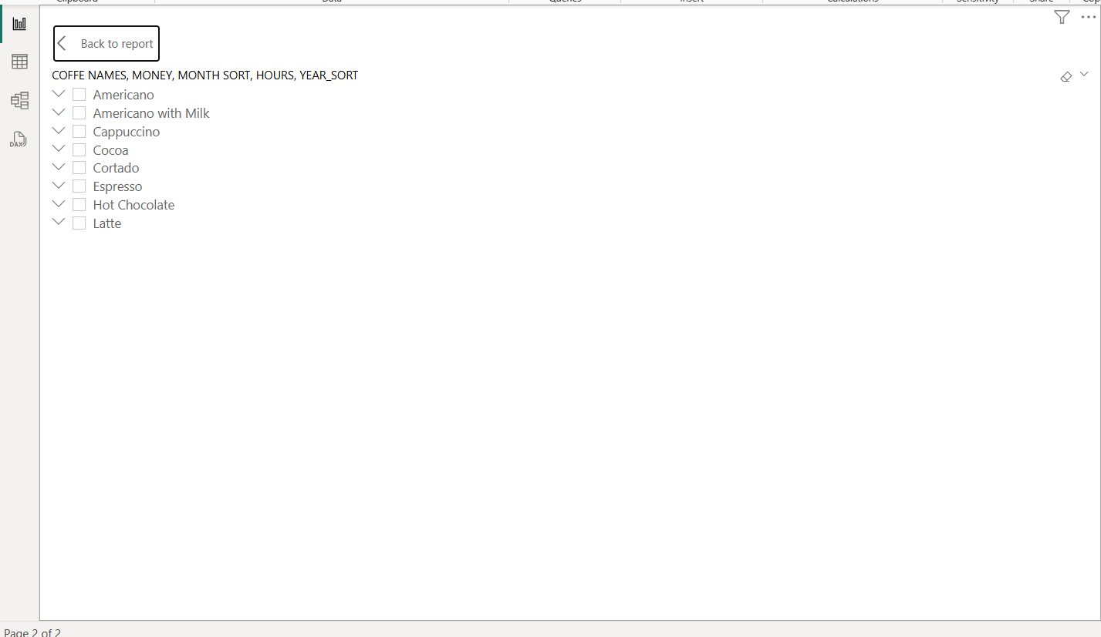

Finally, the Dashboard is in the form of pdf

https://drive.google.com/file/d/1lYuO0Pi3wgNulANtdebqMMtJ40TbEEBU/view?usp=drive_link

